CREATING USERS IN IAM
OBJECTIVE-
Making user and giving it permission to certain policies
STEP1-
After signing in to you AWS account go to IAM service . Click on the ‘User’ option present there and then click on ‘Create User’ . You will see the page where you are suppose to give user details like. After giving the user name check click on the box below it for providing the use AWS management console. After that yo can either let AWS auto generate a password for you which yo can see later on or custom generate a password . After that click on ‘next’.
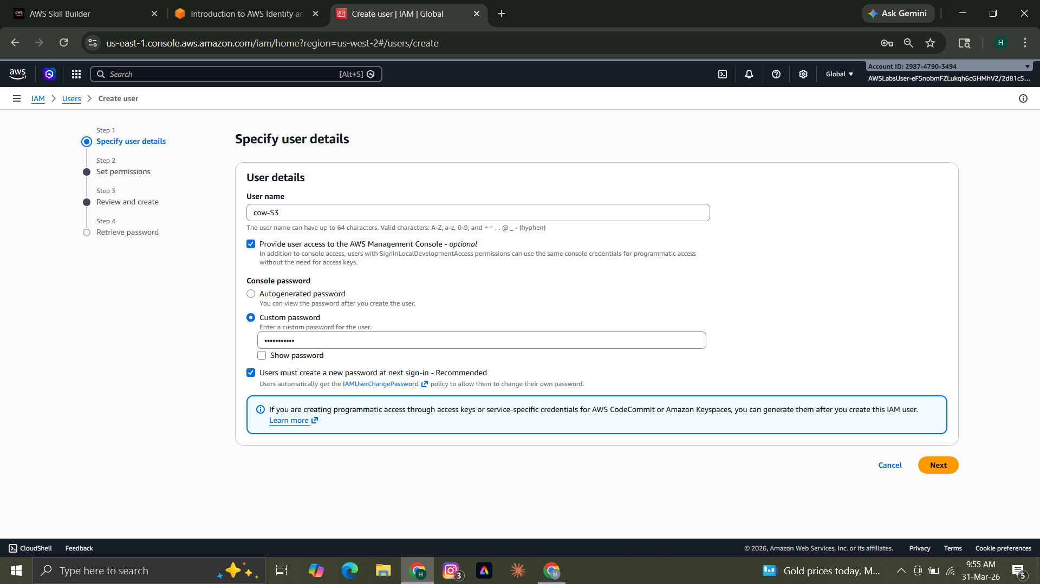
STEP2-
After that select the ‘Attach policies directly’ option to give the user certain permissions. In the ‘permission policies’ box you are supposed to select the permission which yoy want to give to the user.Then click on ‘Next’.
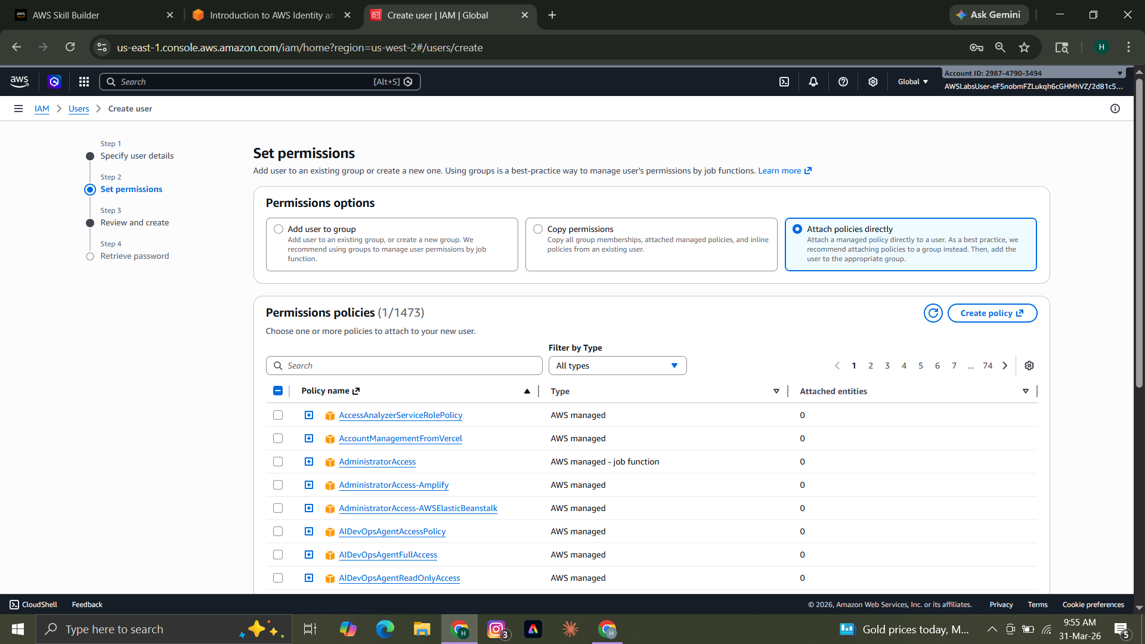
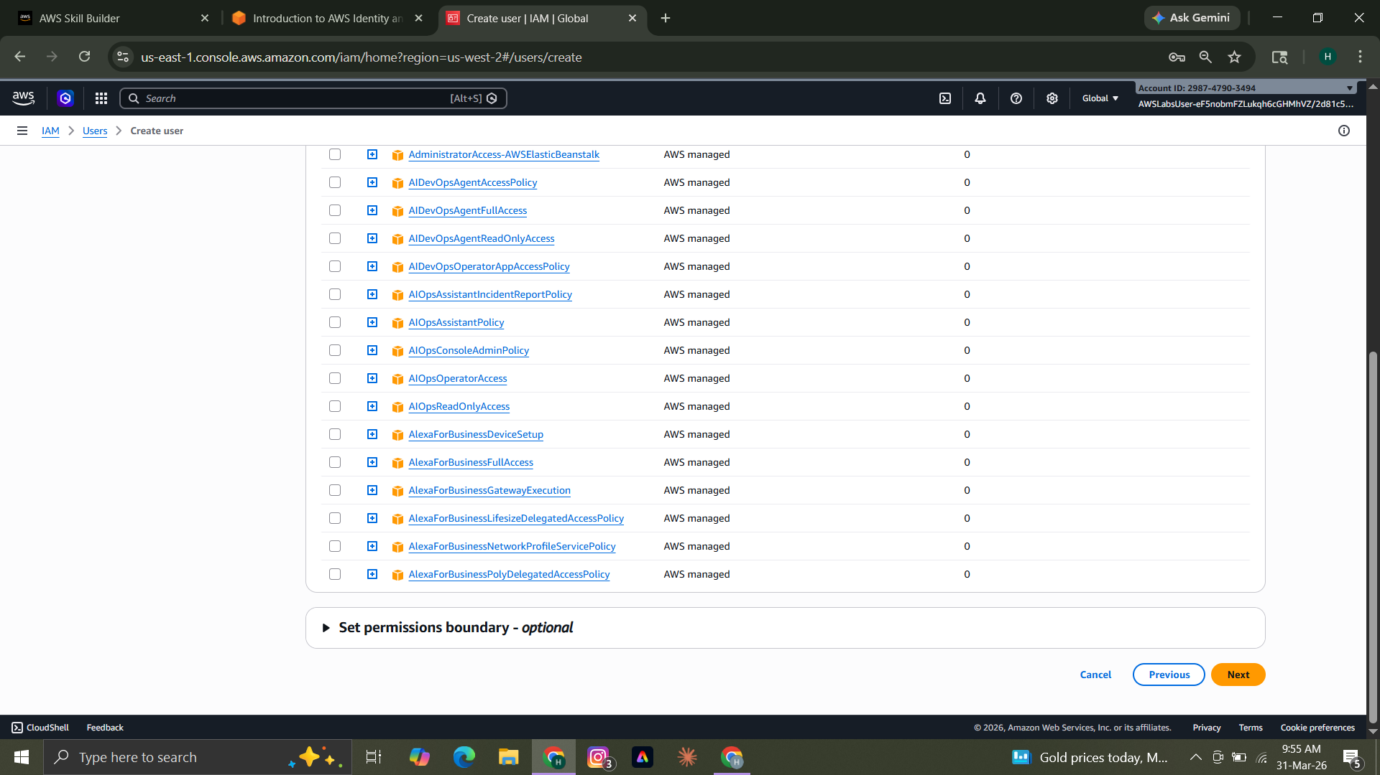
STEP3-
In the next page you will see everything related to the user. Then click on ‘Create user’ and the user would be created.
